VoIP Recorder
Dynamic Link Library Module

Table of Contents
1 Introduction 3
1.1 Overview 3
1.2 Possibilities 3
1.3 Recording method 3
2 Dependency, hardware configuration 5
3 DLL Configuration 6
3.1 Settings node 6
3.2 Devices node 7
3.3 Debug node 7
4 Special features of MultiXTR API 8
4.1 MP_GetSwType 8
4.2 MP_GetDataFormat 8
4.2 MP_GetIfType 8
4.3 MP_GetAudioData 9
4.4 MP_SetAudioGain 9

1 Introduction

This document contains the description of dynamic link library (DLL) which implements functionality for recording VoIP calls, and control data in "passive" mode.

1.1 Overview
VoIP Recorder DLL - plug-in designed for operation with Intelligent Recording BackOffice Recorder which carries out capture and decoding of audio and control data in VoIP networks built on the basis of equipment of NEC Infrontia. The library provides interface to captured data for BackOffice Recorder. Capture of data is carried out in "Passive" mode.

The library captures and analyzes UDP packets received from mirror port of network switch. When SIP packets are detected in general flow UDP traffic, on the basis of its content and direction detects terminals registered in VoIP network and active calls.
Capture and detection of audio data transferred via RTP protocol is produced on the basis of information received as a result of SIP packets analysis. Following decoders: G711 Alaw/Mulaw, G722 are used for decoding RTP sessions.

1.2 Possibilities
- Operation with PBX NEC SV8100 and compatible
- Operation with PBX NEC SV8500 and compatible
- Operation with terminals NEC DT700
- Support PBX / terminals working on NEC-SIP protocol (serviceability was checked in frames of equipment provided for testing)
- Support PBX / terminals working on N-SIP protocol (serviceability was checked only in frames of network dumps provided by customer)
- Support of codec G711, G722

Attention! Library can only work in one of the selected mode “default” for NEC-SIP/Generig SIP networks or “nsip” for N-SIP (SV8500)/Generic SIP.

1.3 Recording method
Passive recording is done by tapping into the computer network. Usually this is done by connecting to a router, switch, hub on the network, or through the PC attached to the VoIP phone. One way of doing this is by connecting to the SPAN (Switched Port ANalyzer) port which allows the VoIP recording PC to monitor all network traffic and pick out only the VoIP traffic to record. This is usually done by connecting an Ethernet cable being between the VoIP recording unit and the router, switch, or hub. Via the SPAN port, the recorder will "sniff" for signaling and RTP packets that have the identifying information contained in the headers of the packets is designated to record.

There are two main ways to capture the RTP packets with the SPAN port. You can SPAN the VoIP Gateway port, giving you all the in/out bound traffic and offers one point of contact for recording.

2 Dependency, hardware configuration

The module uses WinPcap library and also its driver to capture network packets. Thus before using the module it is necessary to install the latest version of this library into the system where it is planned to use it.

The computer with BackOffice Recorder should be connected to mirror port of the switch to which PBX and terminals are connected. The mirror port (SPAN port in Cisco terminology) should be configured and adjusted in appropriate way by means of the switch control interface.

3 DLL Configuration

Module configuration is performed by means of configuration file in XML format. The file should be located in following location:

ALLUSERS\APPDATA\Intelligent recording\Configuration

Name of file by default 6DDAC049-A676-4508-893D-DE181FB29127.xml
Sample of configuration file:

<?xml version="1.0" encoding="UTF-8"?>
<engine guid="6DDAC049-A676-4508-893D-DE181FB29127">
<settings>
<entry name="capture-device">\Device\NPF_{8B734F92-7A1F-43D1-9AC3-C94D55841624}</entry>
<entry name="pbx-ip">192.168.5.11</entry>
<entry name="sip-port">5060</entry>
<entry name="mode">default</entry>
</settings>
<devices>
<device name="\Device\NPF_{8B734F92-7A1F-43D1-9AC3-C94D55841624}" description="Realtek RTL8168C(P)/8111C(P) PCI-E Gigabit Ethernet NIC" index="0" />
<device name="\Device\NPF_{EB68AA3B-2F9C-4213-A524-70F4AEC0068C}" description="Realtek RTL8139 Family PCI Fast Ethernet NIC" index="1" />
<device name="\Device\NPF_{8637789E-7E3C-468C-A8ED-5C1070B30644}" description="VMware Virtual Ethernet Adapter for VMnet1" index="2" />
</devices>
<debug>
<entry name="capture-from-file">d:\debug\test-capture.pcap</entry>
<entry name="write-raw-sip">d:\debug\raw-capured-SIP.pcap</entry>
</debug>
</engine>

Main section - engine, parameter guid shall be equal to 6DDAC049-A676-4508-893D-DE181FB29127.

3.1 Settings node
The «settings» section contains set of records (<entry> nodes), parameter name which is responsible for title of the installed parameter, and value content.

Parameters which should be installed before plug-in initialization (call MP_Open ()) in this section are following:

capture-device - Specifies, what network interface is connected to reflecting port of switch i.e. from what interface to capture UDP packets.

The value of this parameter should be one of enlisted titles of devices in section <devices>, for example «\Device\NPF _ {8B734F92-7A1F-43D1-9AC3-C94D55841624}».

pbx-ip - IP address of the main device. IP address of the main device is needed for correct detection of registered IP terminals, and also to reduce loading on SIP packet parser since potential SIP are considered only those packets UDP packets which are sent to the main device or received from main device.

sip-port - Number of network port for SIP protocol. Not mandatory parameter if it is not specified, port 5060 by default is used.

mode - DLL Operation mode, “default” for NEC-SIP (SV8100)/Generic-SIP, and “nsip” for SV8500 PBX.

3.2 Devices node
The section «devices» contains the list of network devices detected by the library during loading by host-process. The Host application should not change this section; this section is used only to transfer the list of devices to host application. The Host application uses this information for indication of correct interface for capture by means of parameter capture-device of "settings" section.

The plug-in updates this section itself when loaded by application, (DLL_PROCESS_ATTACH). before initialization of plug-in by means of MP_Open functions the application should read the list of devices from configuration file and set capture-device parameter.

3.3 Debug node
Similarly to section «settings» the section «debug» contains set of records (<entry> nodes), parameter name which is responsible for indication of the installed parameter, and content of value.

capture-from-file - If path to .pcap is specified then capture will not occurred from network device, but packets from the specified file will be read instead.

write-raw-sip - If the file name is specified, then captured SIP packets will be saved in this file.

debug-log - If the name of file is specified then plug-in will return debug information into this file.

4 Special features of MultiXTR API

Thru to the fact that interface provided by plug-in for host application (further MultiXTR API) is general-purpose both for VoIP modules, and for modules working with analog or digital PBX, implementation of some functions of this interface has special features. It is caused by that some concepts applicable to traditional telephony, are not always applicable to VoIP, or may have other meaning.

4.1 MP_GetSwType
Function returns string containing the type of plug-in. The string contains the equipment manufacturer`s code supported by plug-in, hardware interface and type of audio coding. since in VoIP networks various terminals can use various standards for coding of audio data and instructions of the supported protocol simultaneously, in our case the string «NEISIP» is used, where:

NE - hardware manufacturer, I - VoIP, SIP - the protocol.

4.2 MP_GetDataFormat
Original assignment of function - to return code of format used by connected telephone system. In case of VoIP telephony as written above, various terminals can use various standards for audio coding. Therefore the parameter returned by this function should be interpreted as «Format of audio data returned by plug-in». That is a format used by plug-in to transfer audio data to the application.

Admissible values: WAVE_FORMAT_MULAW for American µ-law, or WAVE_FORMAT_ALAW for European A-law.

You can configure the type format used by plug-in to return data, at the stage of its compilation by means of preprocessor directives.

4.2 MP_GetIfType
Returns string containing characteristics of registered terminal. It is formed similarly to the string of returned function MP_GetSwType. Since PBX may have possibility to work not only with NEC-SIP terminals but also with standard SIP terminals, or terminals of other vendors, this function returns «UNISIP» (UN - unknown vendor, I - VoIP, SIP - the protocol) for registered terminals but not supported by plug-in. For supported terminals using NEC-SIP protocol, the string «NEISIP» is returned.

4.3 MP_GetAudioData
Function returns captured audio data in format defined by MP_GetDataFormat. Audio data is returned in 3 streams.

PBXData - The data received from PBX
PhoneData - The data received from phone
MergedData - mixed data received from phone and PBX

In VoIP networks terminals do not obligatory transfer media data through PBX and, on the contrary, to reduce load of channels whenever possible transfer audio data directly between terminals. Accordingly the data received from PBX, shall be considered as data received from remote terminal or terminals. The way how plug-in mixs captured and decoded RTP sessions in case with one terminal are associated to more than one call – object is displayed in the following chart:

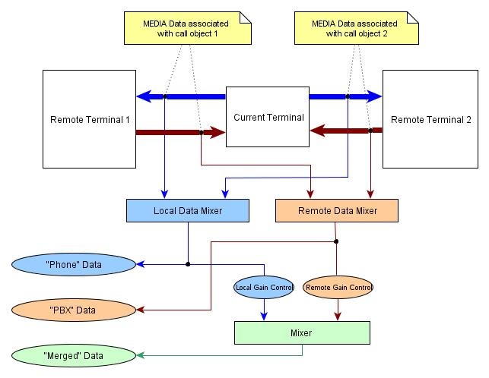
Fig. 1

4.4 MP_SetAudioGain
This function increases or reduces audio signal on one of streams returned MP_GetAudioData. On the previous chart you can clearly see how the configured value influences the returned data. In case if MP_SetAudioGain is called for "local" stream, then the value set by calling this function influences on PhoneData stream. If for "remote" then influences on PBXData stream.

